Link đoạn ChatGPT:
Link Repo Github:

LAB 2 – HOMEWORK 1 _{(PHAM NGOC THACH – 24521592)}
- _{Work Breakdown Structure (WBS)}
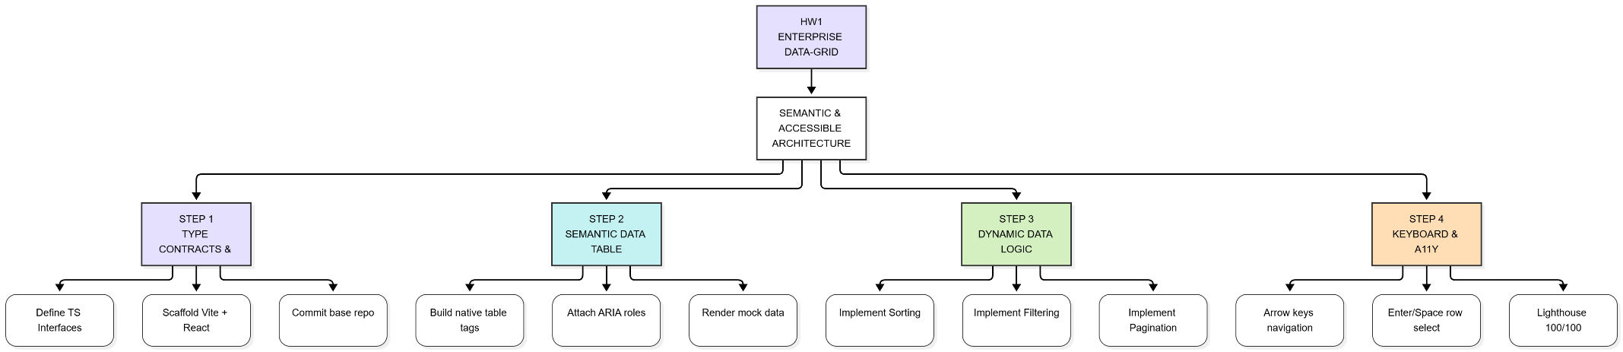
- Screenshot
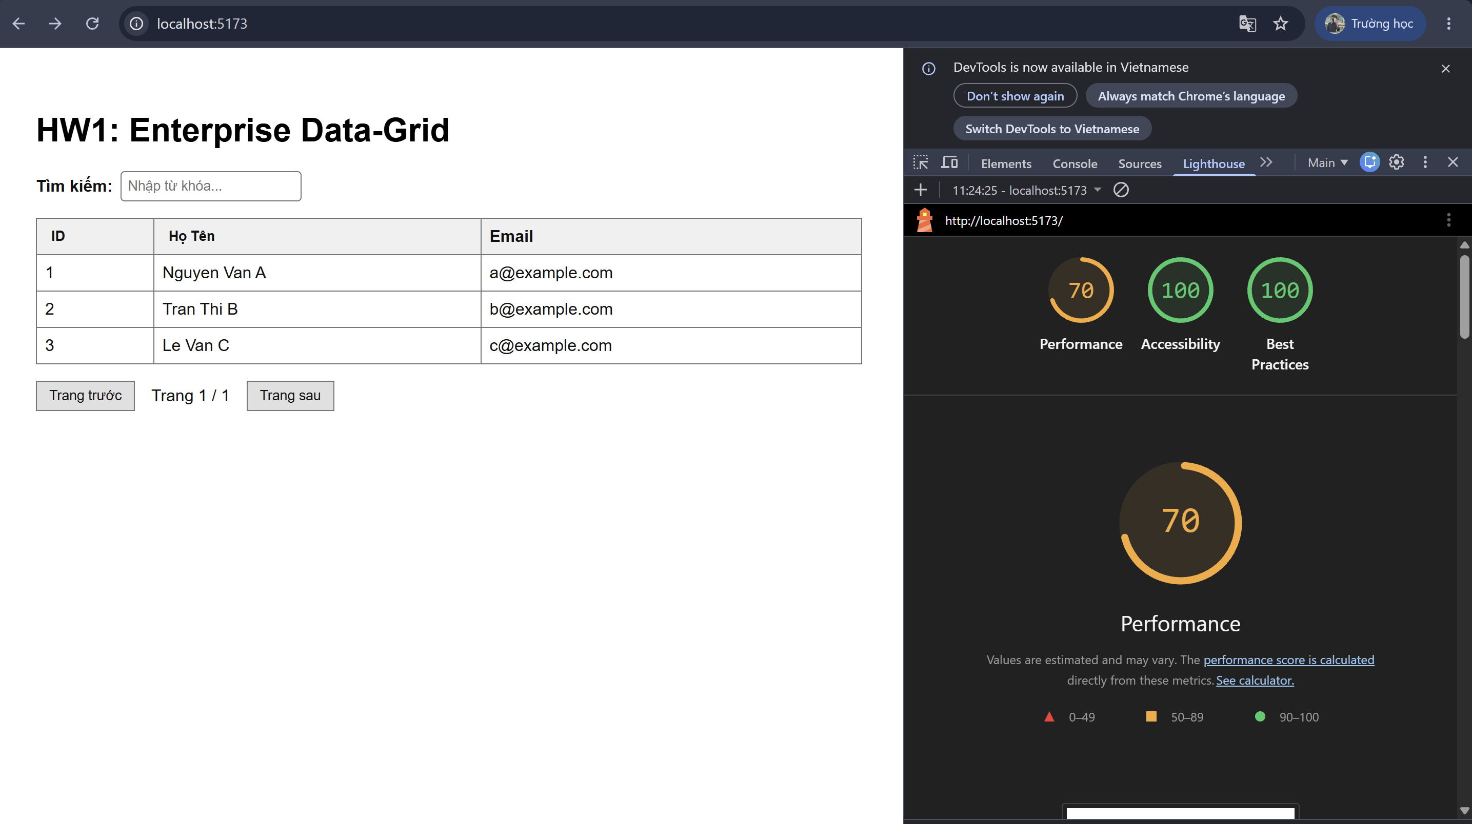

LAB 1 – HOMEWORK 2 _{(PHAM NGOC THACH – 24521592)}
- _{Work Breakdown Structure (WBS)}
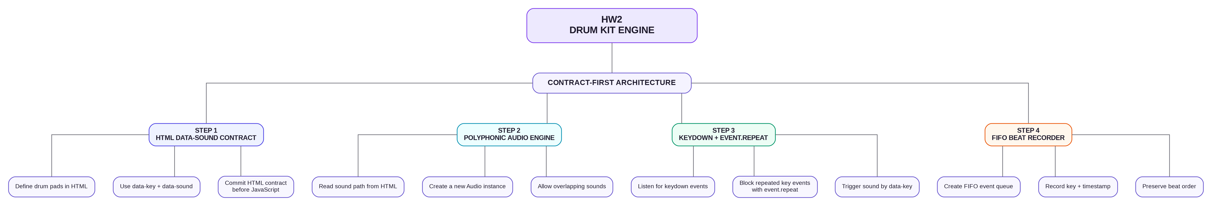
- Screenshot
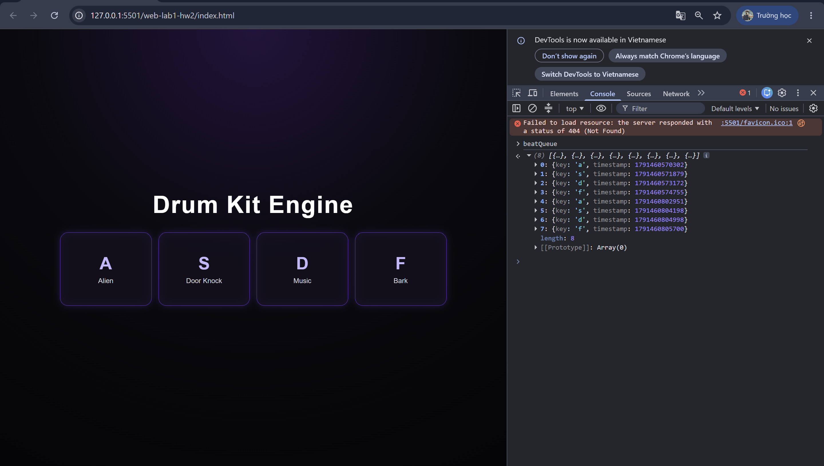

LAB 1 – HOMEWORK 3 _{(PHAM NGOC THACH – 24521592)}
- _{Work Breakdown Structure (WBS)}
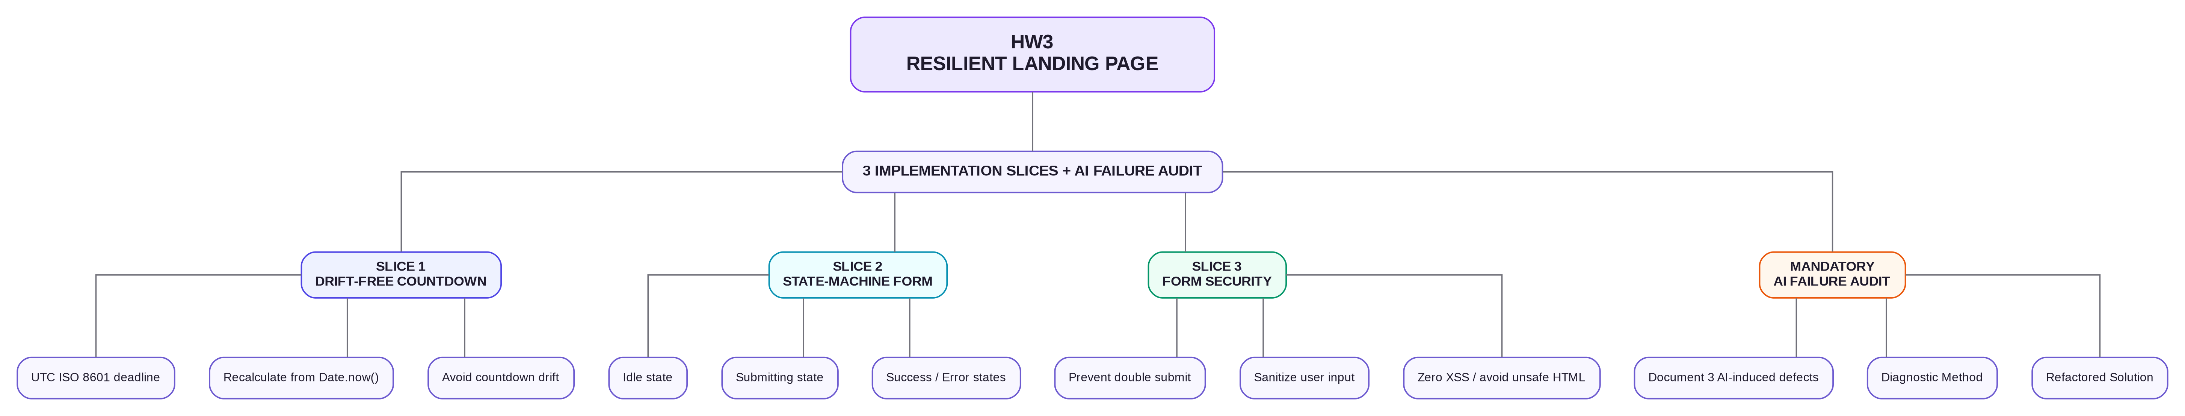
- _{Screenshot}
